“Sexual Health and STI/HIV Risk Assessment Survey" via QuestionPro

**Purpose:** To identify risk factors that negatively impact condom use among college students

**Research Question(s):**

1. Does the use of emergency contraceptives negatively impact condom use among college students?
2. Does the use of dating apps increase the number of sexual partners among college students?
3. Is there a relationship between risky sexual behaviors and the use of dating apps among college students?
4. Do college students utilize the college health campus services for STI/HIV testing?
5. Are sexually active college students who have a history of contracting an STI or are HIV-positive using condoms consistently?

**Target journals:**

* **(1)** Journal of College Health **(2)** Sexually Transmitted Disease **(3)** Health Education Journal

**Demographic Table**

Survey Sample (N = 122)

|  |  |  |  |
| --- | --- | --- | --- |
| Variables | *n* | Percent | Cumulative Percent |
| **Gender** |  |  |  |
| Male | 66 | 54.1 | 54.1 |
| Female | 53 | 43.5 | 97.6 |
| Other (transgender/transsexual) | 3 | 2.4 | 100.0 |
|  |  |  |  |
| **Age** |  |  |  |
| 18–24 | 86 | 70.5 | 70.5 |
| 25–35 | 36 | 29.5 | 100.0 |
| **Mean Age 22.6** |  |  |  |
|  |  |  |  |
| **Ethnicity** |  |  |  |
| American Indian/Alaskan Native | 15 | 12.3 | 12.3 |
| Asian | 21 | 17.2 | 29.5 |
| Black/African American | 12 | 9.8 | 39.3 |
| Hispanic/Latino/a | 16 | 13.1 | 52.5 |
| Middle Eastern | 2 | 1.6 | 54.1 |
| White/European American | 55 | 45.1 | 99.2 |
| Other | 1 | .8 | 100.0 |
|  |  |  |  |
| **Marital Status** |  |  |  |
| Single | 91 | 74.6 | 75.8 |
| Married | 27 | 22.1 | 22.5 |
| Separated | 2 | 1.6 | 1.7 |
| **Total** | **120** | **98.4** | 100.0 |
| Missing | 2 | 1.6 |  |
| **Geographic area** |  |  |  |
| Urban | 111 | 90.9 | 90.9 |
| Rural/Small town | 11 | 0.9 | 100.0 |
|  |  |  |  |
| **Academic Status** |  |  |  |
| Freshman | 18 | 14.8 | 15 |
| Sophomore | 21 | 17.2 | 17.5 |
| Junior | 20 | 16.4 | 16.6 |
| Senior | 39 | 32 | 32.5 |
| Graduate (Masters) | 21 | 17.2 | 17.5 |
| Graduate (Doctorate) | 1 | 0.8 | 0.9 |
| **Total** | **120** | **98.4** | 100.0 |
| Nonstudent | 1 | 0.8 |  |
| Missing | 1 | 0.8 |  |

**Asked 122 Participants about Dating Apps and Sexual Partners**

**68** Participants had 1 or more sex partner(s) from a dating app

41 – Males

25 – Females

2 – Transgender

**The number of times various “Dating Apps” were identified by participants who met sex partners from a dating app**

|  |  |
| --- | --- |
| Dating App |  |
| Bumble | 22 |
| Other Social Media Networks | 20 |
| Facebook | 11 |
| Tinder | 9 |
| Hinge | 5 |
| Twitter | 3 |
| Grinder | 2 |
| OKCupid | 1 |
| Tumblr | 1 |
| Pure | 1 |
| Pinterest | 1 |
| TAIMI | 1 |

**Note:** Key for “Other Social Media Networks” = Participants referenced meeting a sexual partner via the *“internet”* or *“on the web”.*

**Sexual Health History Table**

Sample (N = 122)

|  |  |  |  |
| --- | --- | --- | --- |
| Variables | *n* Percent | Variables | *n*  Percent |
| **Sexual orientation** |  | **Worried more about pregnancy or STI?** |  |
| Straight / Heterosexual | 96 78.7 | Unplanned pregnancy | 41 33.6 |
| Gay / Lesbian | 10 8.2 | Contracting an STI | 40 32.7 |
| Other (bisexual/pan/a-)  N/A – no answer | 15 12.3  1 .8 | Both  Neither | 32 26.2  9 7.5 |
|  |  |  |  |
| **Sexual engagement** |  | **Ever met a sexual partner from dating app** |  |
| Oral sex | 42 34.5 |  |  |
| Vaginal sex  Anal sex | 41 33.6  36 29.5 | Yes  No | 68 55.7  54 44.3 |
|  |  |  |  |
|  |  | **Met sex partner on dating app (by gender)**  Males  Females  Transgender | 41 60.2  25 36.8  2 3.0 |
|  |  |  |  |
| **Age at sexual debut** |  | **# of sex partners using dating app**  None | 34 27.9 |
| 13y or younger | 3 2.4 | 1–2 partners | 30 24.6 |
| 14y–15y | 35 28.6 | 3–4 partners | 30 24.6 |
| 16y–17y | 36 29.5 | 5–6 partners | 8 6.5 |
| 18y–19y | 31 25.4 | 7 or more partners | 5 4.1 |
| 20y or older  N/A - no answer | 17 14.1 | N/A (no answer) | 15 12.3 |
|  |  |  |  |
| **# of sex partners in past year** |  | **# of lifetime sex partners** |  |
| 0–1 partner | 36 29.5 | 1–2 partner | 44 36.1 |
| 2–3 partners | 45 36.9 | 3–4 partners | 44 36.1 |
| 4 partners | 22 18.0 | 5–6 partners | 11 9.0 |
| 5 or more partners | 9 7.4 | 7 or more partners | 22 18.0 |
| Uncertain of # of partners  N/A - no answer | 10 8.2 | Uncertain of partners  N/A - no answer | --  1 0.8 |
|  |  |  |  |
| **Use a condom last sexual activity** |  | **Aware of UTA Student Health clinic** |  |
| Yes | 82 67.7 | Yes | 101 83.0 |
| No | 40 32.3 | No | 21 17.0 |
|  |  |  |  |
| **Drink alcohol or use any other controlled substance last sexual activity?** |  | **Ever received STI/HIV screening at UTA Student Health clinic** |  |
| Yes | 43 35.0 | Yes | 64 52.5 |
| No  N/A - no answer | 79 65.0 | No | 58 47.5 |
|  |  |  |  |
| **Ever had STI testing?** Yes | 18 14.7 | **Ever tested positive for STI?** Yes | 21 17.2 |
| **Ever had HIV testing?** Yes | 17 14.0 | **Ever tested positive for HIV?** Yes | 14 11.4 |
| **Ever had STI & HIV testing?** Yes | 49 40.1 | **Never had an STI or HIV?** No | 87 71.4 |
| **Never had STI or HIV testing?** No | 38 31.2 |  |  |
|  |  |  |  |
| **How often do you get STI testing?** |  |  |  |
| Once a year | 49 40.1 |  |  |
| Twice a year | 28 22.9 |  |  |
| More than 2yrs ago or Never | 45 37.0 |  |  |
|  |  |  |  |
|  |  |  |  |

Data Analysis

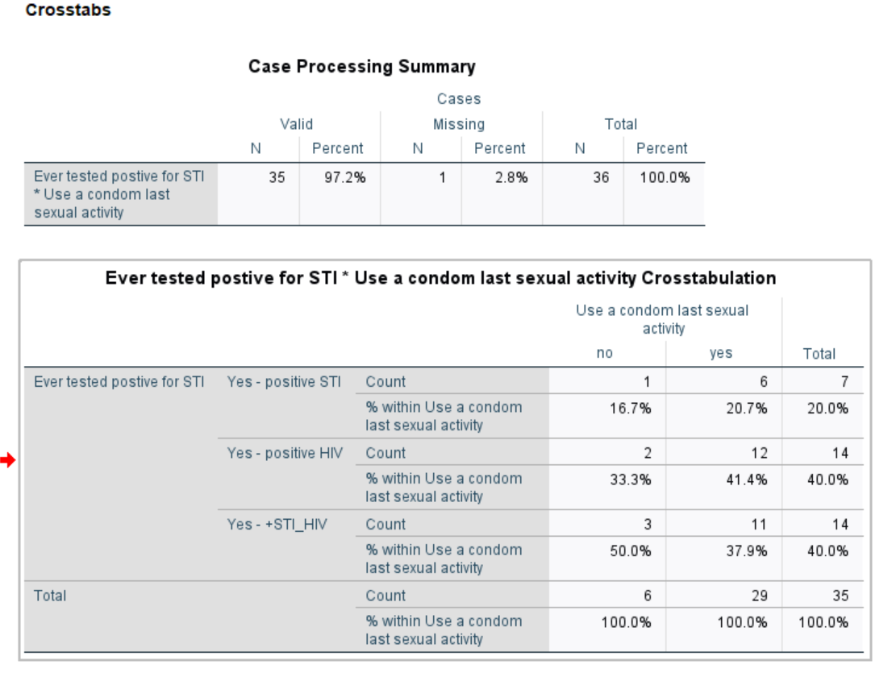

SUMMARY:

Out of 122 participants, 21 (17%) had a previous STI, and 14 (11%) is has tested positive for HIV infection.

A total of 35 participants (28%) have tested positive for an STI or HIV infection.

**Condom Use**

Of the 35 STI or HIV-positive participants, 29 (82%) used a condom during their last sexual activity.

Of the 14 participants who are HIV-positive, _______ used a condom during their last sexual activity.

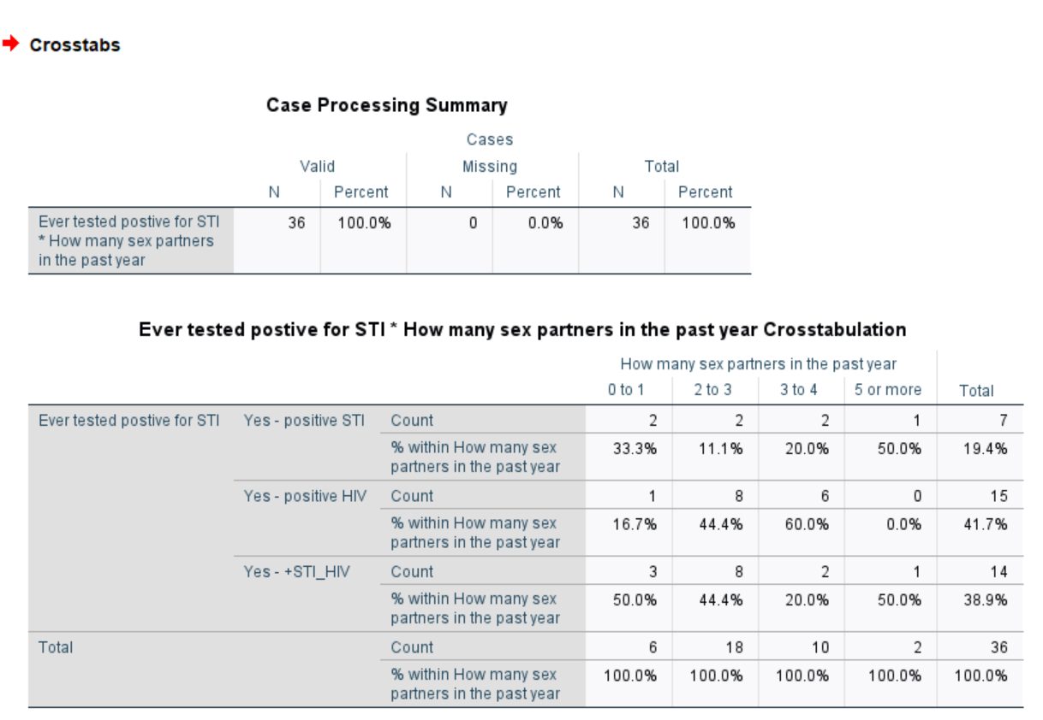

SUMMARY:

Out of the 35 participants with a history of having an STI or are HIV positive, 5 participants had one- lifetime sexual partner; 18 participants had 2-3 lifetime sexual partners; 10 participants had 3-4 lifetime sexual partners and 2 participants had 5 or more lifetime sexual partners.

Of the 14 participants who are HIV positive, 8 had a total of 2-3 sexual lifetime partners and 6 participants had 3-4 lifetime partners.

*Note to self: For participants with 3 or more lifetime sexual partners, it would have been helpful in knowing at what age did they start having sex (their sexual debut).*

**Dating Apps**

Of the 35 STI or HIV-positive participants, 28 (80%) answered YES to having had a sexual partner(s) from a dating app. Of the 14 participants who were HIV-positive, 9 of them had an average of 3 sexual partners they met on a dating app.

**Alcohol of Substance Use with last sexual encounter**

Of the 35 STI or HIV-positive participants, 24 (68%) used alcohol or another form of substance use during their last sexual activity.

**Condom Use**

Of the 35 STI or HIV-positive participants, 24 (68%) used alcohol or another form of substance use during their last sexual activity.

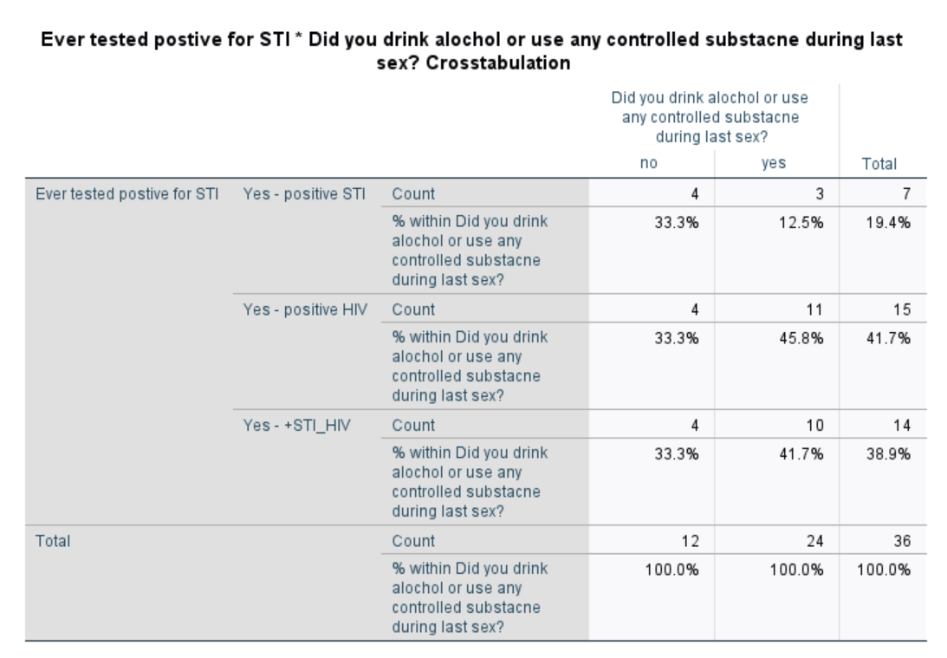

SUMMARY:

**Alcohol of Substance Use with last sexual encounter**

Of the 35 STI or HIV-positive participants, 24 (68%) used alcohol or another form of substance use during their last sexual activity.

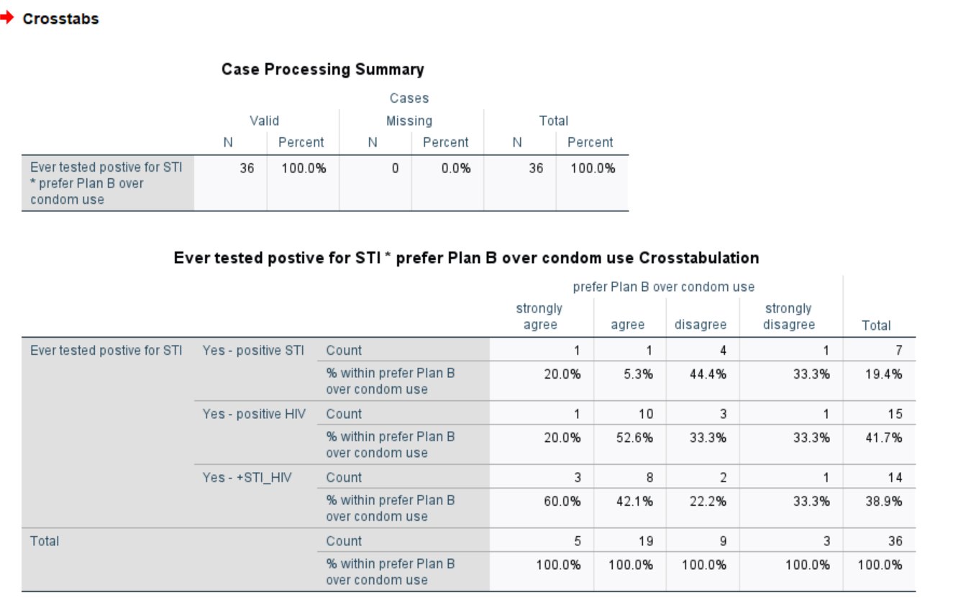

SUMMARY:

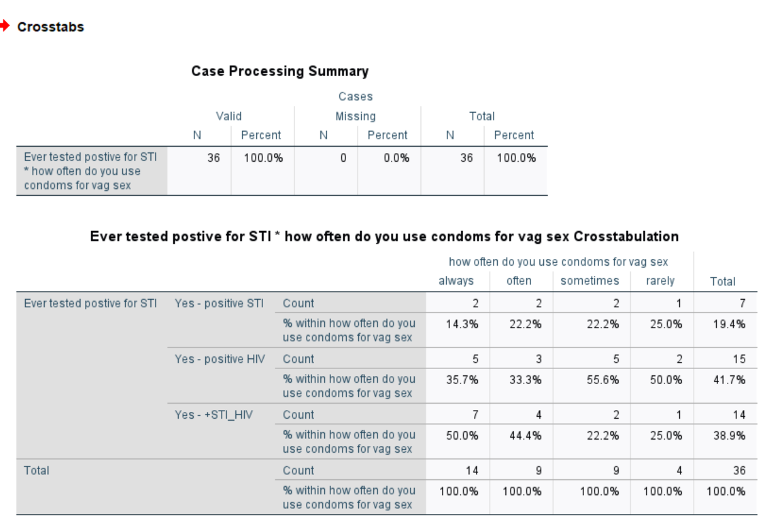

SUMMARY:

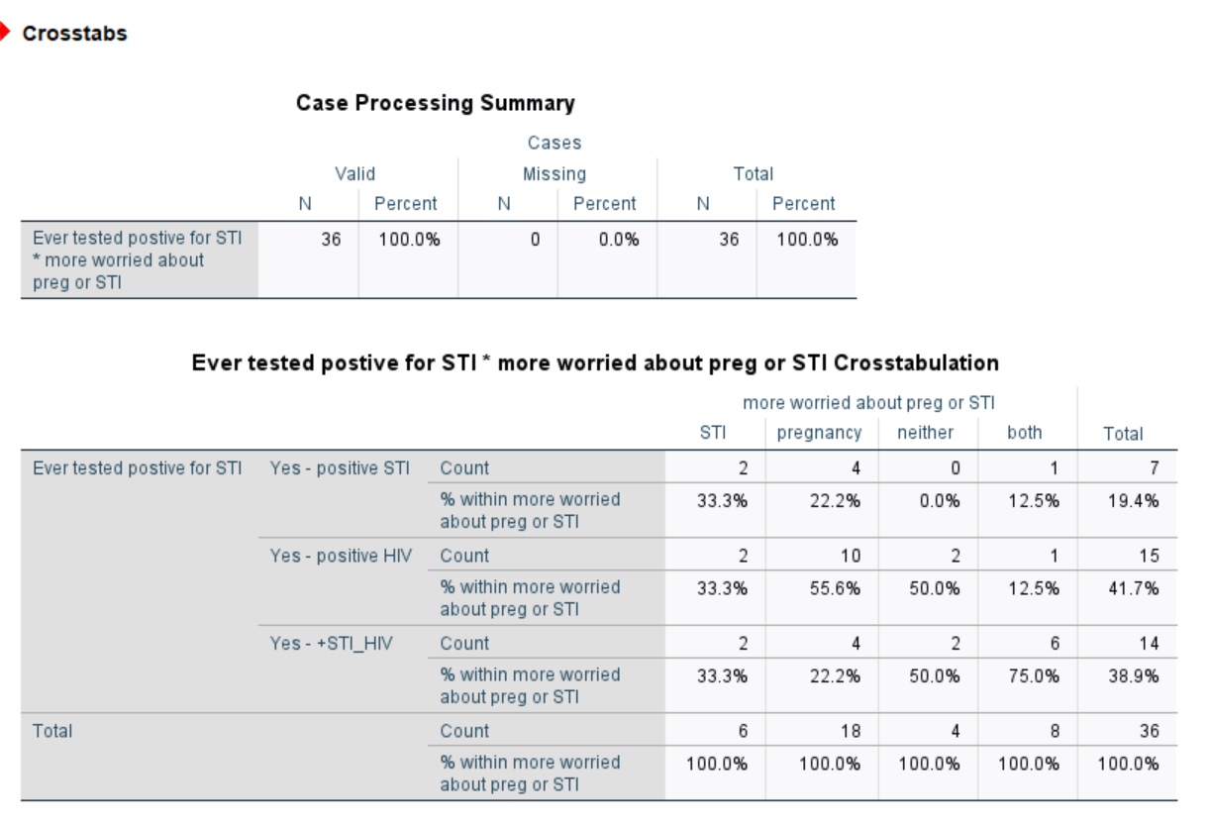

SUMMARY:

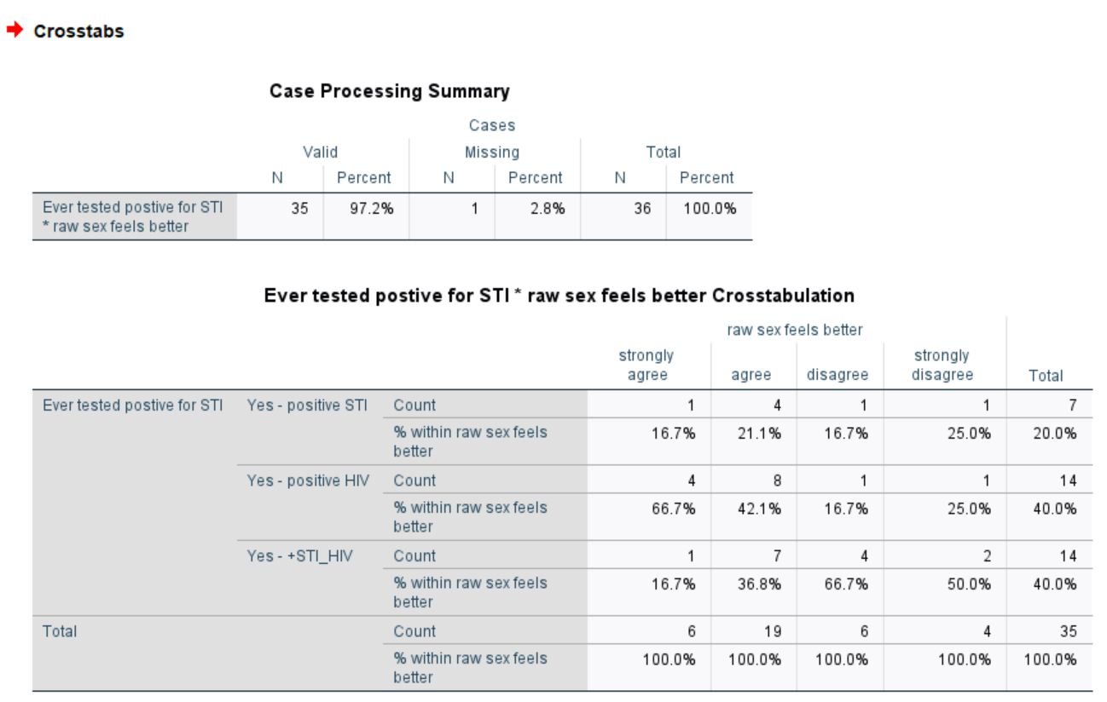

SUMMARY:

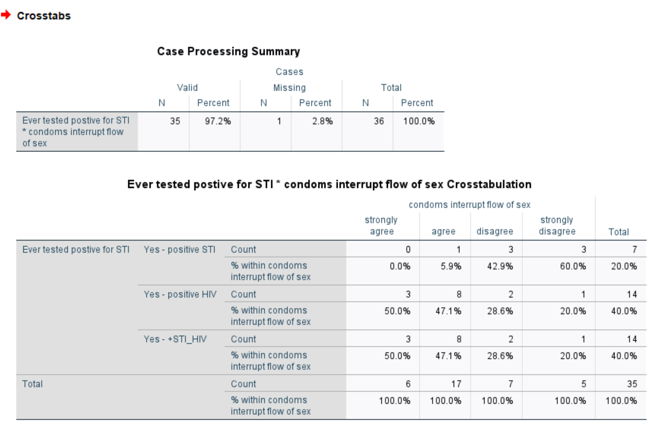

SUMMARY:

**Logistic Regression - Awareness of UTA HEal**

|  |  |  |
| --- | --- | --- |
| **Notes** | | |
| Output Created | | 30-AUG-2022 22:28:50 |
| Comments | |  |
| Input | Data | D:\Risky Sexual Behaviors_8.30.22 (revised codes).sav |
| Active Dataset | DataSet1 |
| Filter | <none> |
| Weight | <none> |
| Split File | <none> |
| N of Rows in Working Data File | 122 |
| Missing Value Handling | Definition of Missing | User-defined missing values are treated as missing |
| Syntax | | LOGISTIC REGRESSION VARIABLES STI_HIVtest  /METHOD=ENTER UTHC_aware UTHC_serv  /CLASSPLOT  /CASEWISE OUTLIER(2)  /PRINT=GOODFIT CI(95)  /CRITERIA=PIN(0.05) POUT(0.10) ITERATE(20) CUT(0.5). |
| Resources | Processor Time | 00:00:00.06 |
| Elapsed Time | 00:00:00.02 |

|  |  |  |  |
| --- | --- | --- | --- |
| **Case Processing Summary** | | | |
| Unweighted Casesa | | N | Percent |
| Selected Cases | Included in Analysis | 121 | 99.2 |
| Missing Cases | 1 | .8 |
| Total | 122 | 100.0 |
| Unselected Cases | | 0 | .0 |
| Total | | 122 | 100.0 |
| a. If weight is in effect, see classification table for the total number of cases. | | | |

|  |  |
| --- | --- |
| **Dependent Variable Encoding** | |
| Original Value | Internal Value |
| No | 0 |
| Yes | 1 |

**Block 0: Beginning Block**

|  |  |  |  |  |  |
| --- | --- | --- | --- | --- | --- |
| **Classification Tablea,b** | | | | | |
|  | Observed | | Predicted | | |
|  | Ever had STI or HIV testing | | Percentage Correct |
|  | No | Yes |
| Step 0 | Ever had STI or HIV testing | No | 0 | 38 | .0 |
| Yes | 0 | 83 | 100.0 |
| Overall Percentage | |  |  | 68.6 |
| a. Constant is included in the model. | | | | | |
| b. The cut value is .500 | | | | | |

|  |  |  |  |  |  |  |  |
| --- | --- | --- | --- | --- | --- | --- | --- |
| **Variables in the Equation** | | | | | | | |
|  | | B | S.E. | Wald | df | Sig. | Exp(B) |
| Step 0 | Constant | .781 | .196 | 15.910 | 1 | <.001 | 2.184 |

|  |  |  |  |  |  |
| --- | --- | --- | --- | --- | --- |
| **Variables not in the Equation** | | | | | |
|  | | | Score | df | Sig. |
| Step 0 | Variables | Aware of UTA HC | 3.101 | 1 | .078 |
| Received services at UTA HC | 12.748 | 1 | <.001 |
| Overall Statistics | | 13.218 | 2 | .001 |

**Block 1: Method = Enter**

|  |  |  |  |  |
| --- | --- | --- | --- | --- |
| **Omnibus Tests of Model Coefficients** | | | | |
|  | | Chi-square | df | Sig. |
| Step 1 | Step | 13.452 | 2 | .001 |
| Block | 13.452 | 2 | .001 |
| Model | 13.452 | 2 | .001 |

|  |  |  |  |
| --- | --- | --- | --- |
| **Model Summary** | | | |
| Step | -2 Log likelihood | Cox & Snell R Square | Nagelkerke R Square |
| 1 | 137.146a | .105 | .148 |
| a. Estimation terminated at iteration number 4 because parameter estimates changed by less than .001. | | | |

|  |  |  |  |
| --- | --- | --- | --- |
| **Hosmer and Lemeshow Test** | | | |
| Step | Chi-square | df | Sig. |
| 1 | 8.395 | 2 | .015 |

|  |  |  |  |  |  |  |
| --- | --- | --- | --- | --- | --- | --- |
| **Contingency Table for Hosmer and Lemeshow Test** | | | | | | |
|  | | Ever had STI or HIV testing = No | | Ever had STI or HIV testing = Yes | | Total |
| Observed | Expected | Observed | Expected |
| Step 1 | 1 | 7 | 9.105 | 10 | 7.895 | 17 |
| 2 | 20 | 17.895 | 20 | 22.105 | 40 |
| 3 | 3 | .895 | 1 | 3.105 | 4 |
| 4 | 8 | 10.105 | 52 | 49.895 | 60 |

|  |  |  |  |  |  |
| --- | --- | --- | --- | --- | --- |
| **Classification Tablea** | | | | | |
|  | Observed | | Predicted | | |
|  | Ever had STI or HIV testing | | Percentage Correct |
|  | No | Yes |
| Step 1 | Ever had STI or HIV testing | No | 7 | 31 | 18.4 |
| Yes | 10 | 73 | 88.0 |
| Overall Percentage | |  |  | 66.1 |
| a. The cut value is .500 | | | | | |

|  |  |  |  |  |  |  |  |  |  |
| --- | --- | --- | --- | --- | --- | --- | --- | --- | --- |
| **Variables in the Equation** | | | | | | | | | |
|  | | B | S.E. | Wald | df | Sig. | Exp(B) | 95% C.I.for EXP(B) | |
| Lower | Upper |
| Step 1a | Aware of UTA HC | .354 | .527 | .451 | 1 | .502 | 1.424 | .507 | 3.999 |
| Received services at UTA HC | 1.386 | .441 | 9.869 | 1 | .002 | 3.998 | 1.684 | 9.490 |
| Constant | -.142 | .455 | .098 | 1 | .754 | .867 |  |  |
| a. Variable(s) entered on step 1: Aware of UTA HC, Received services at UTA HC. | | | | | | | | | |

Step number: 1

Observed Groups and Predicted Probabilities

80 + +

I I

I I

F I I

R 60 + Y +

E I Y I

Q I Y I

U I Y I

E 40 + Y Y +

N I Y Y I

C I Y Y I

Y I Y Y I

20 + N Y +

I Y N Y I

I Y N N I

I N N N N I

Predicted ---------+---------+---------+---------+---------+---------+---------+---------+---------+----------

Prob: 0 .1 .2 .3 .4 .5 .6 .7 .8 .9 1

Group: NNNNNNNNNNNNNNNNNNNNNNNNNNNNNNNNNNNNNNNNNNNNNNNNNNYYYYYYYYYYYYYYYYYYYYYYYYYYYYYYYYYYYYYYYYYYYYYYYYYY

Predicted Probability is of Membership for Yes

The Cut Value is .50

Symbols: N - No

Y - Yes

Each Symbol Represents 5 Cases.

|  |
| --- |
| **Casewise Lista** |
|  |
| a. The casewise plot is not produced because no outliers were found. |